APPROVED

POSSIBLE

DISCARDED

Guidelines that can define level design in FPS/Hack ‘n Slash:

* **Heatmap & Hot spot**

<https://yuhuinnovation.maps.arcgis.com/apps/MapJournal/index.html?appid=b89b59ef0ad14534aae4e5fc85fdb2eb#>

* **Deathmap**
* **Death map depending on** enemy type, etc (not in picture, but a table)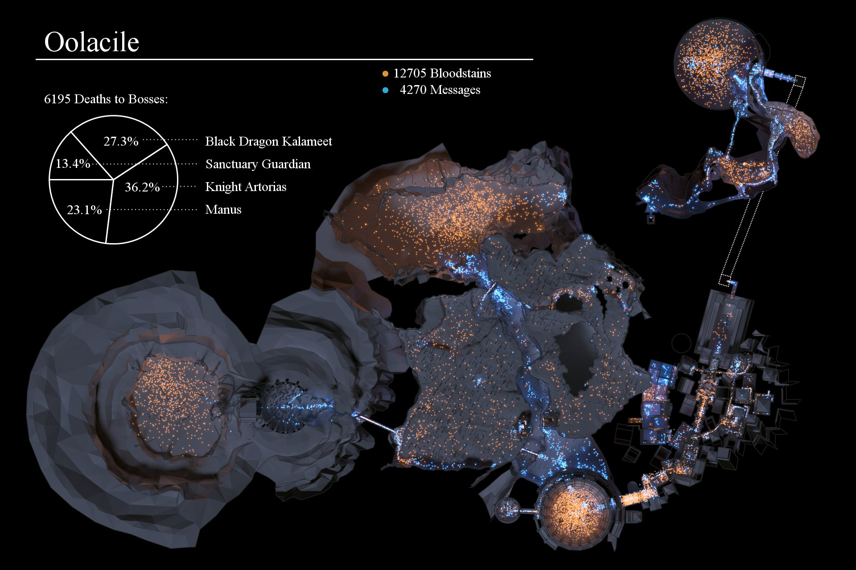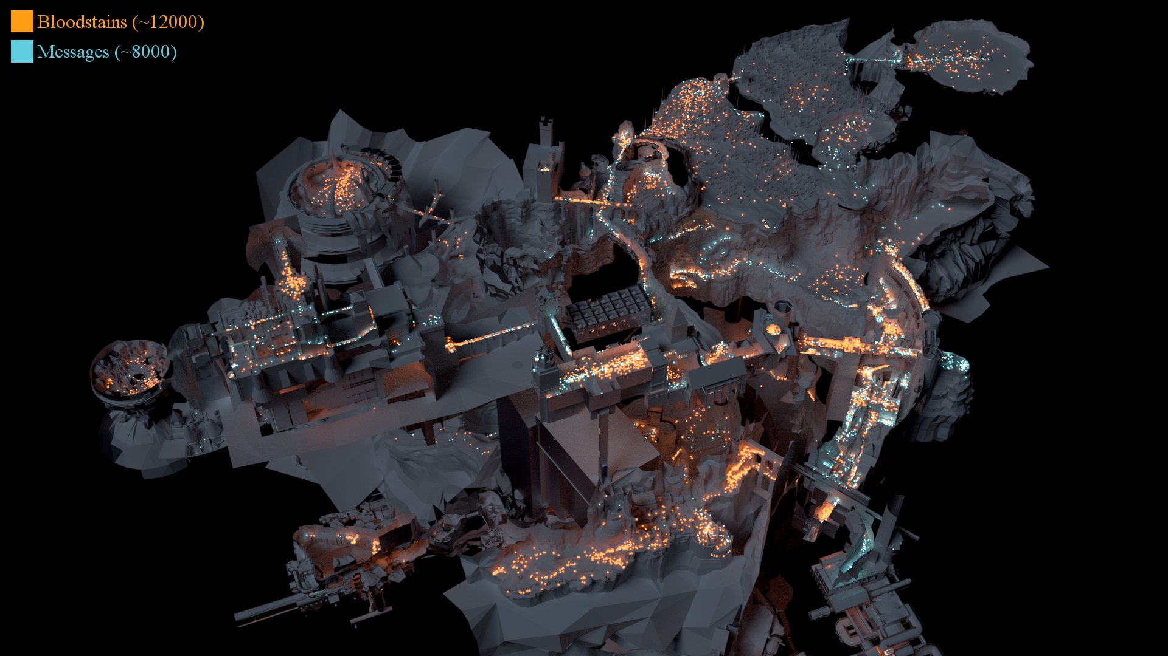
* **Player paths**

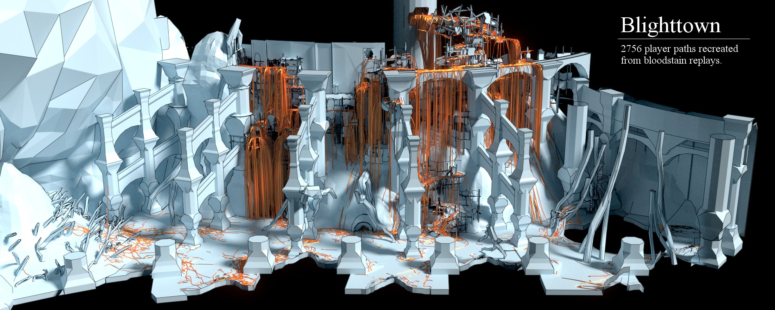

* **Player time paths** (time spend going from A to B and then stopping, how much time the player stopped...)



* **Height map**: time spend on each floor, enemy kills on each floor...

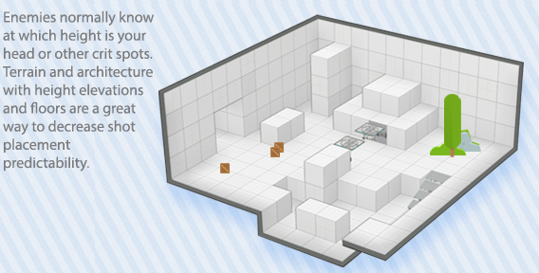

* **Difficulty (deaths?) as a function of time and/or level advancement**

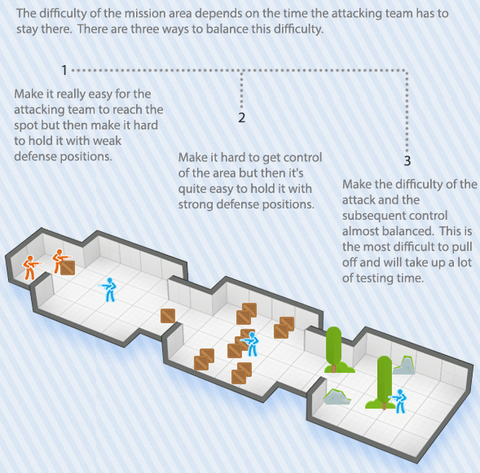

* **Spawn**: when the player dies, how long does it take for them to re-enter combat? How “safe” is the respawn area? (DOOM middle of combat vs other games respawn in a safe base in the edge of the map)

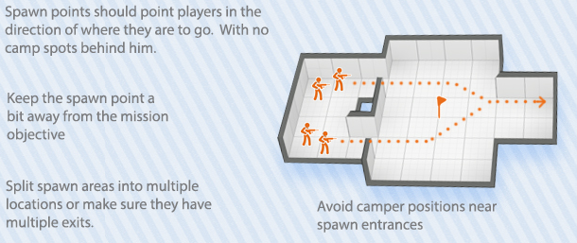

* **Stoppers**: we can tag stopper objects, they serve to prevent the player from escaping the map. Thus, we can calculate the players’ collision time with the stopper and their facing direction to calculate if they are stuck trying to access an area behind

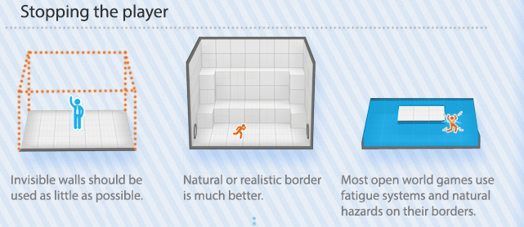

* **Item recognition maps**: we tag an area to act as a “room” and calculate how much time does the player spend before acquiring an item (health, money, weapon…) and we check how many of the items present in the room were acquired. A technique to track the visualization could be the player’s camera and occlusion with obstacles

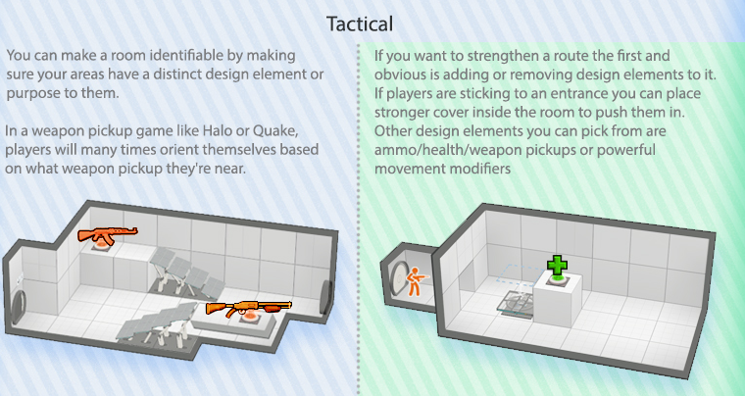

* **Focal point map**: objects tagged as an “focal/interest point” use to have a function: button to open a door, the door itself, an easter egg, furniture to guide the player… Thus, the player is sometimes meant to trace a trajectory that follows those points and we can at calculate the closest distance to each one and, most importantly, if those focal points where followed by the intended order (once the player gets to <x distance to the point it is considered as visited) or if some of them were ignored. A spline/curve can be defined with the optimal path and we can compare the one the player made and therefore adjust those focal points (...)

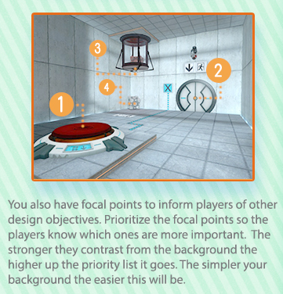

* **Cognitive theory**: shape, lightning, color… The AI that tests the map represents a human and therefore it experiences a series of emotions through player type data

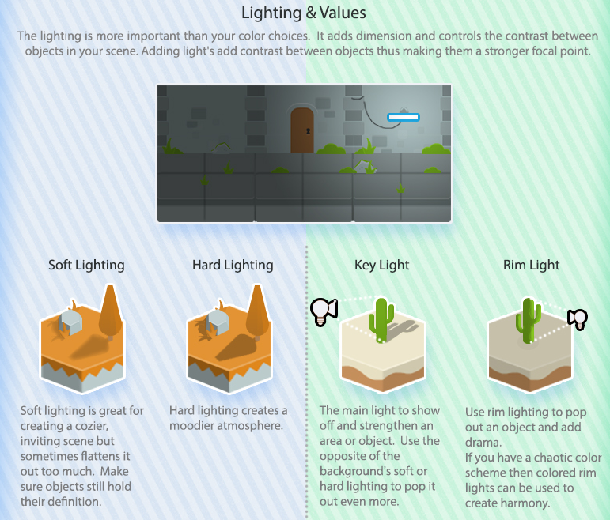

We can calculate the emotional flow of the level taking into account how “intense” each action is, if it is positive or negative, which is the actual emotional state: fear, panique, expertise… All of them alter the AI’s gameplay in a different manner and it would be presented at the end of the simulation as a chart

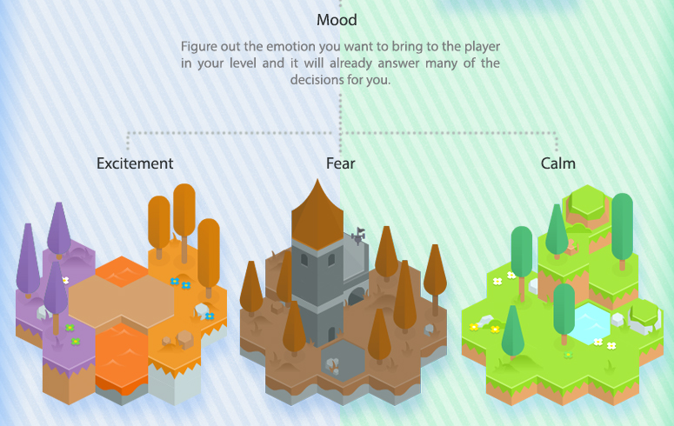

* **Map depends on AI’s strength and player type + stats:** to simulate suitable automated playtest sessions, many different player types ought to be selected and they will be considered in the AI’s logic

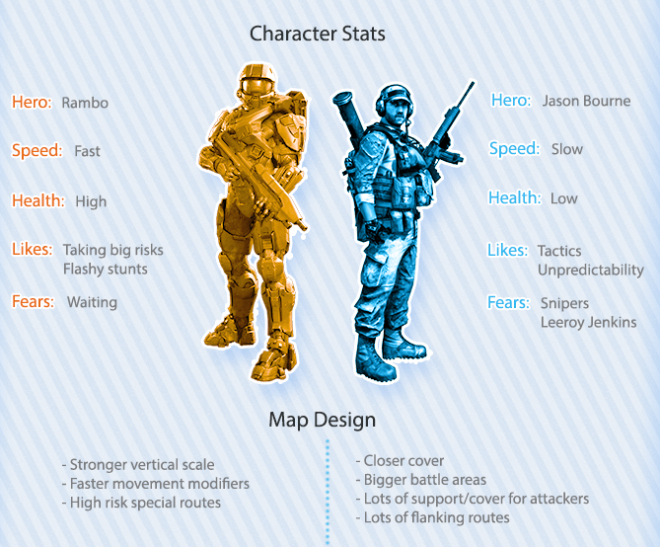

* **Rewarding:** many items can be tagged as having a “reward” factor and can even feel more rewarding in certain moments of the gameplay. They AI would have a certain need for those rewards and its’ confidence/temper would be boosted.

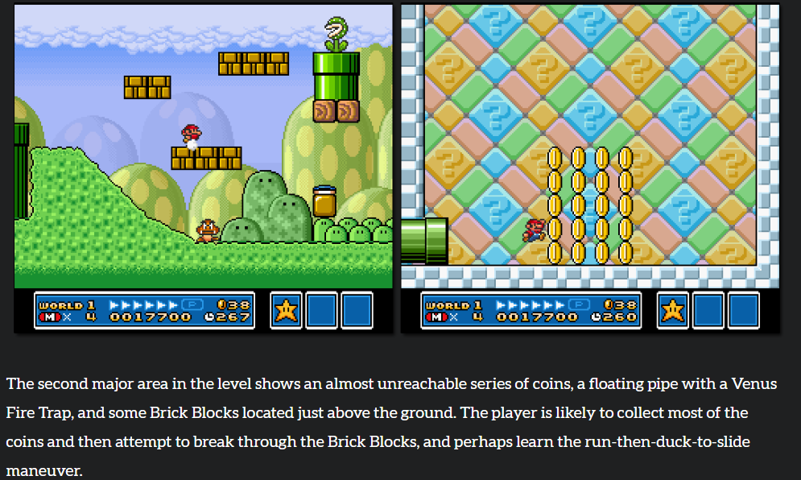

* **Power-ups**: the AI would be either pre-programmed with some token actions that can be unlocked at a certain point in the level (eg double jump, buff attacks…) or the logic would let the user “code” an ability for the player. Either way, there would be situations where each ability must be used, either by the level itself or by enemy weaknesses. For instance, the dev team could want to check how an ability that shoots rays in random directions affects a specific kind of enemy. The AI’s “attack functions” would be accessible for the developer to manipulate

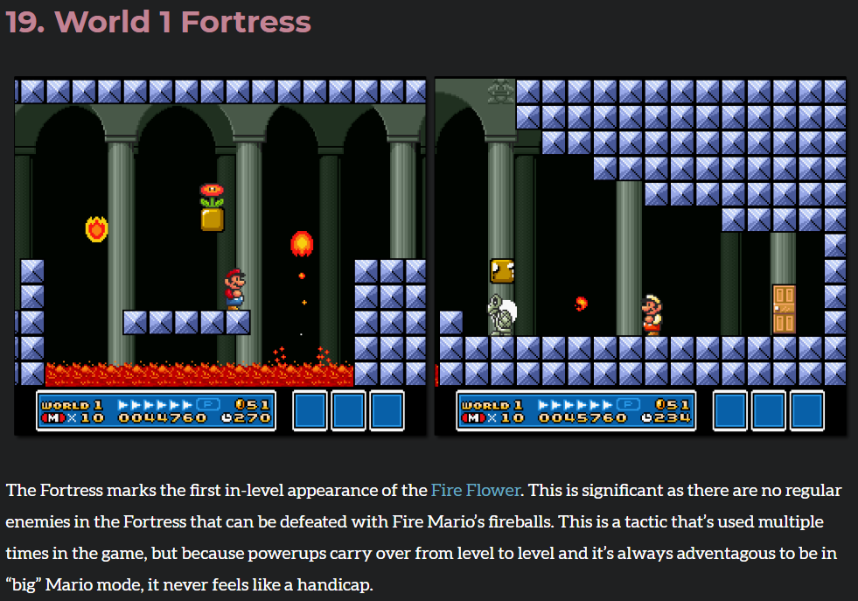

**Simple heatmap in Unreal Engine**

<https://www.youtube.com/watch?v=QL51f8qdsm8&feature=emb_logo>

**References**

<https://twitter.com/RazorOfArtorias/status/1265633293107675137/photo/1>

<https://www.finereport.com/en/data-visualization/top-10-map-types-in-data-visualization.html#7_Time-Space_Distribution_Map>

<https://yuhuinnovation.maps.arcgis.com/apps/MapJournal/index.html?appid=b89b59ef0ad14534aae4e5fc85fdb2eb#>

<http://bobbyross.com/library/mpleveldesign>

<http://www.significant-bits.com/super-mario-bros-3-level-design-lessons/>

**Package project in Unreal**

<https://docs.unrealengine.com/en-US/Engine/Basics/Projects/Packaging/index.html>